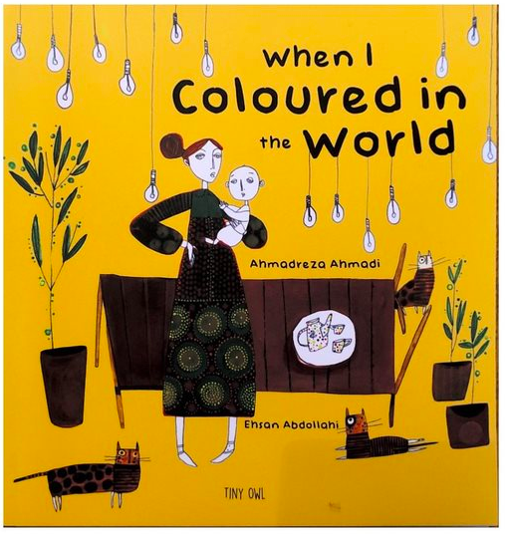
Think of what you would like to change in the world.
Write down word, then rub it out! Choose a colour and write a new word to replace it with.

Colours can make you feel different emotions like happy, sad or angry.
What colour is your new word? How does it make you feel?
What colours don't you like?

Write your own poem with all the new words you have chosen to make the world a better place. Pick your favourite colours and draw / create images which make you happy.

My mum gave me a box of crayons for colouring and an eraser for rubbing out. So guess what I did?

Anger
I rubbed out the word anger.
I wrote the word serenity.

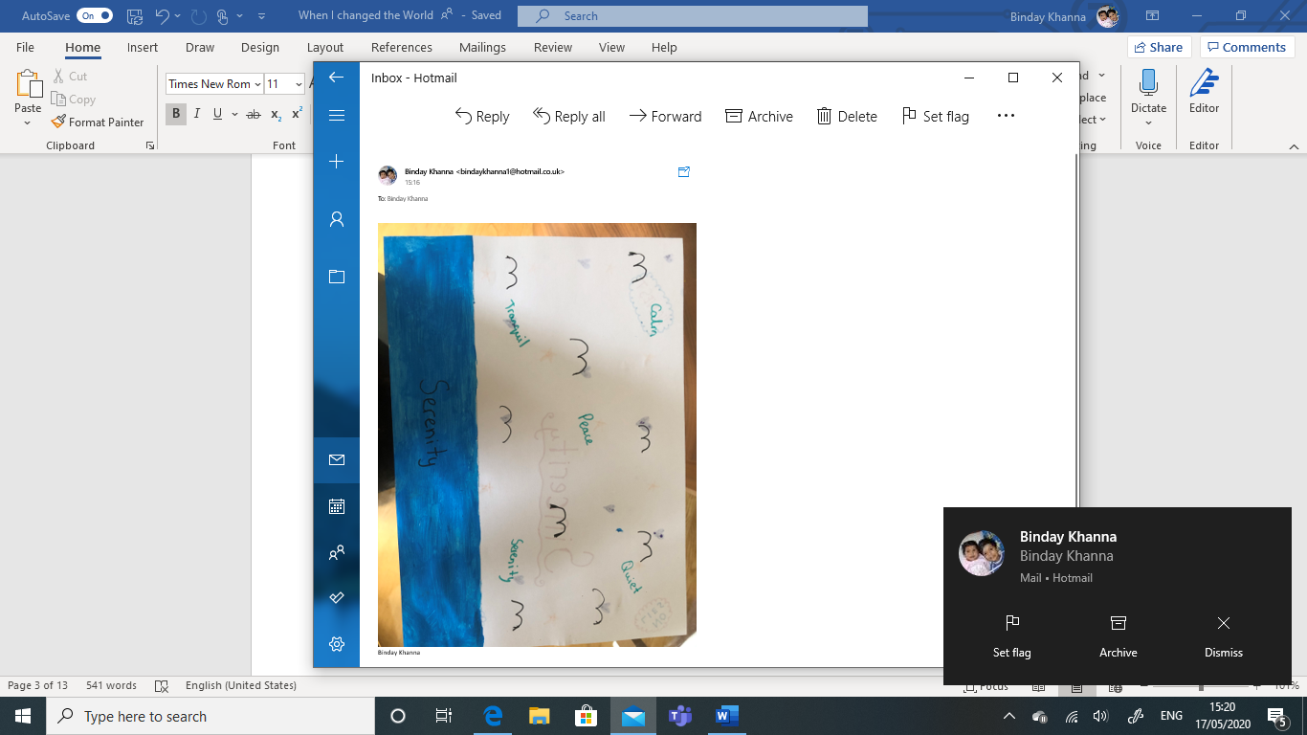
Serenity.
Light blue.
With my light blue crayon, I spread serenity. All over the world, foe became friend and enemy became eternal family. There was a tint of peace in the air. I gave the world light blue.

Imprisoned
I rubbed out the word imprisoned.
I wrote the word free.

Free.
Fuchsia.

With my fuchsia crayon, I set those who were imprisoned free. All over the world, people joyfully raced down the streets leaving a trail of jubilation behind them. I gave the world fuchsia.
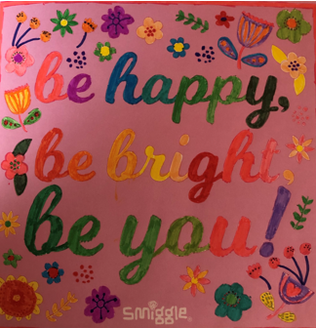
Grief
I rubbed out the word grief.
I wrote the word joy.

Joy.
Yellow.
All over the world, smiles spread across the faces of those who were dismal. People were beginning to feel joy. I gave the world yellow.
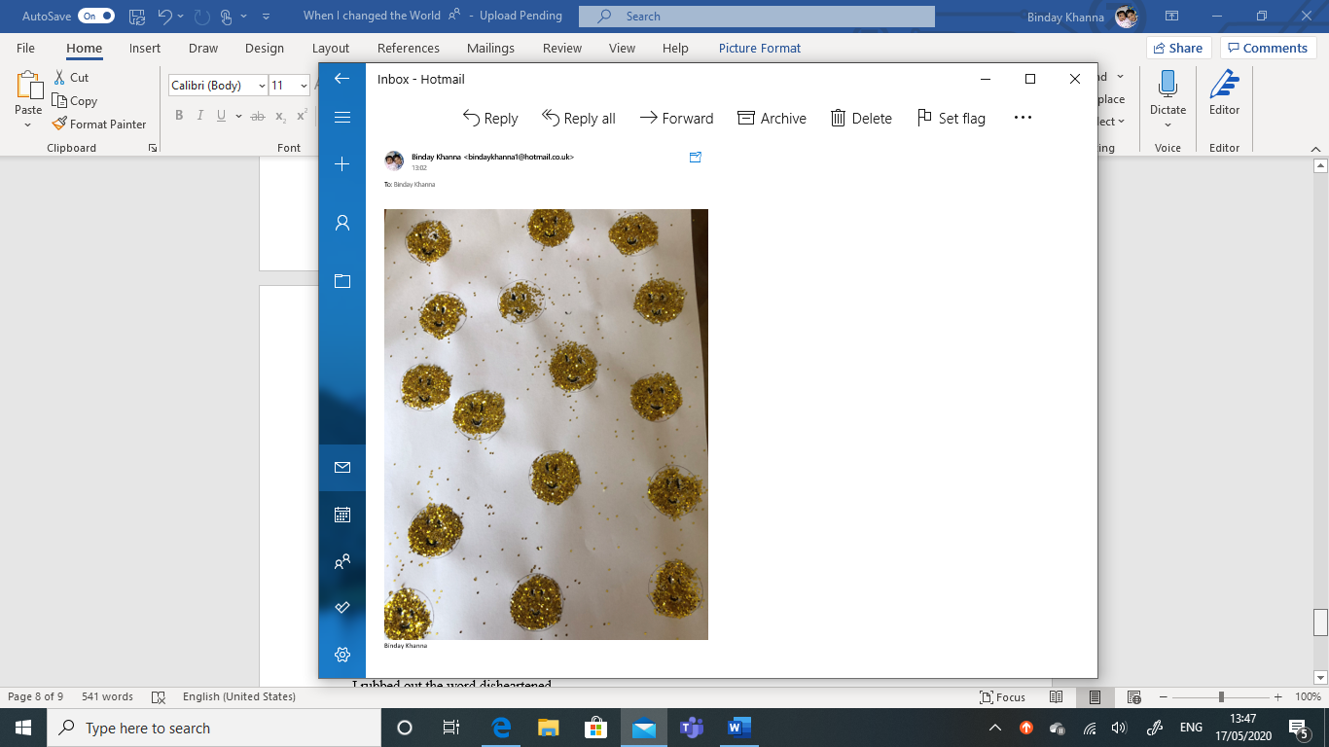

Illness
I rubbed out the word illness.
I wrote the word health.

Health.
Violet.

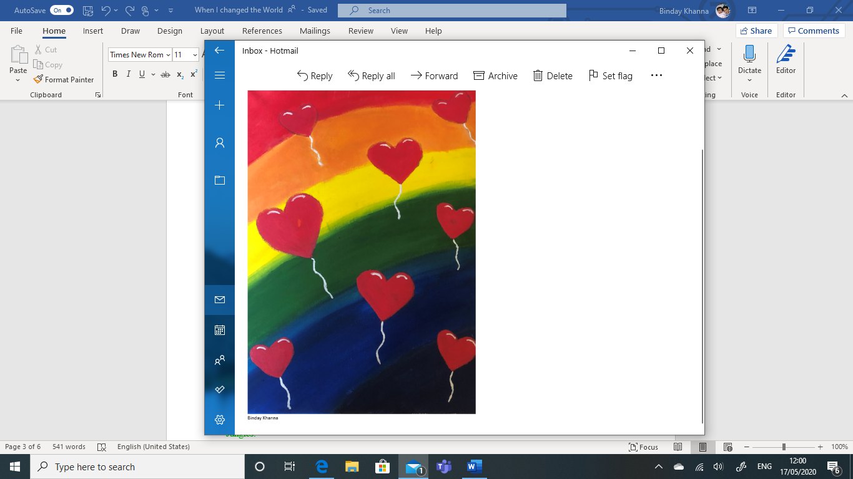
All over the world, those who were ill roamed the streets not even feeling the slightest bit worried. People were given health and comfort. I gave the world violet
Deforestation.
I rubbed out the word deforestation.
I wrote the word jungles.

Jungles.
Emerald.

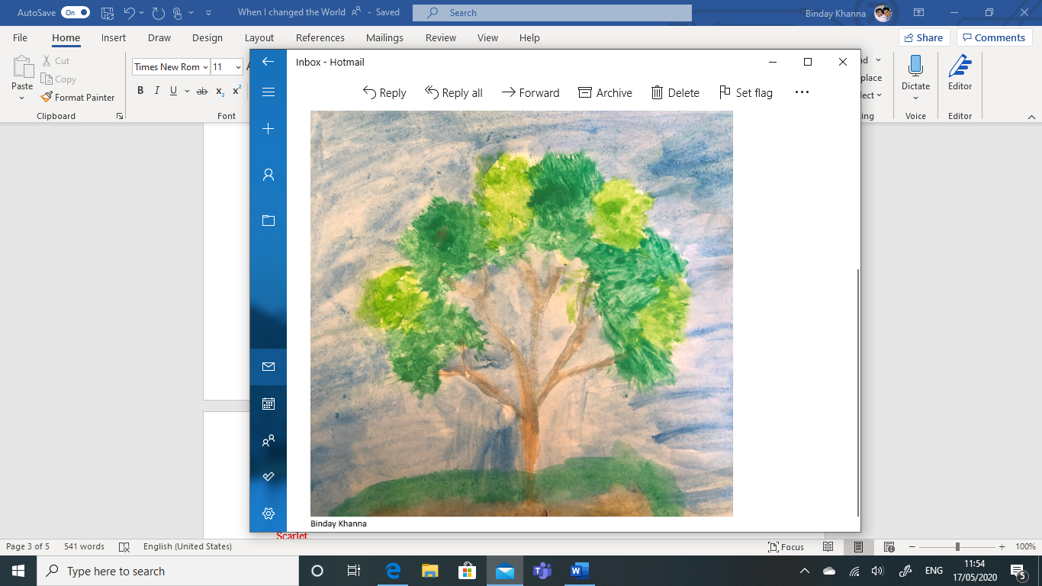
All over the world, jungles started to sprout filling the air with an aroma of fresh flowers, fragrant leaves and earthy grass. I gave the world emerald.
Deceit.
I rubbed out the word deceit.
I wrote the word sincerity.

Sincerity.
Scarlet.

All over the world, people didn’t need to worry about being lied to. There were no enemies in the world and everyone could trust each other. I gave the world scarlet.

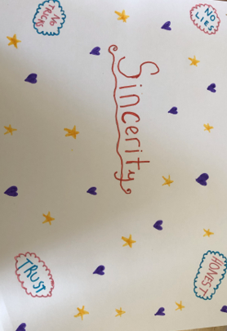

Poverty.
I rubbed out the word poverty.
I wrote the word prosperity.

Prosperity.
Orange.

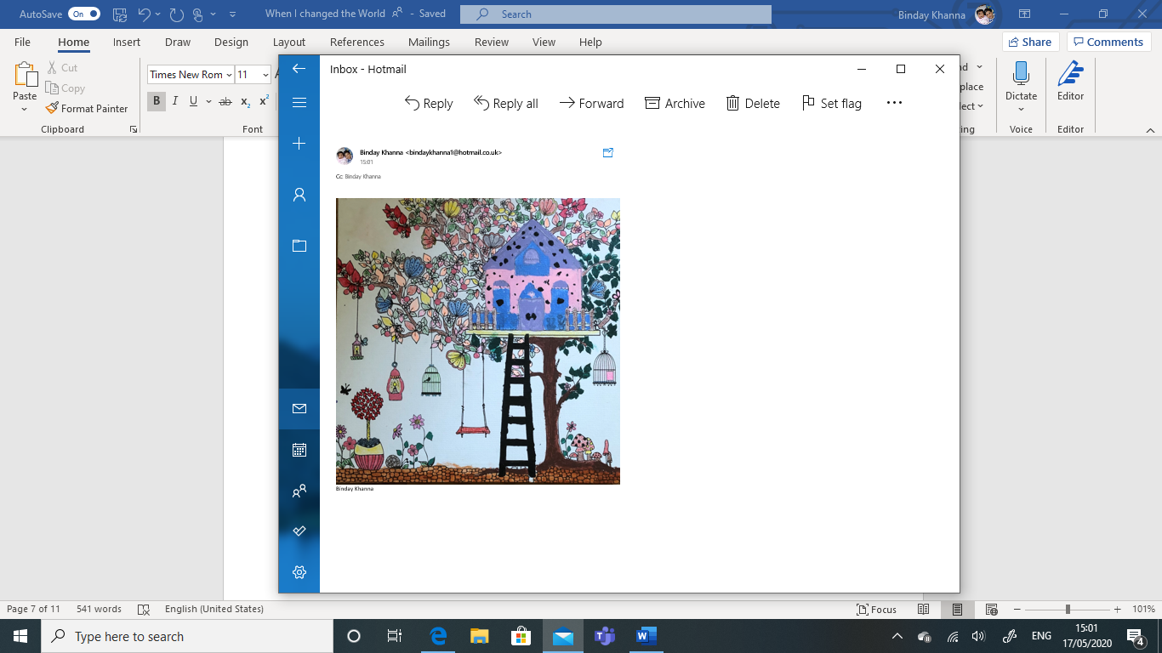
All over the world, the poor were prosperous. There was no such thing as poverty. It was as if it had never been there. I gave the world orange.
Separated.
I rubbed out the word separated.
I wrote the word united.

United.
Gold.
All over the world, people came together as one. As one family. As one community. As one mind. I gave the world gold.

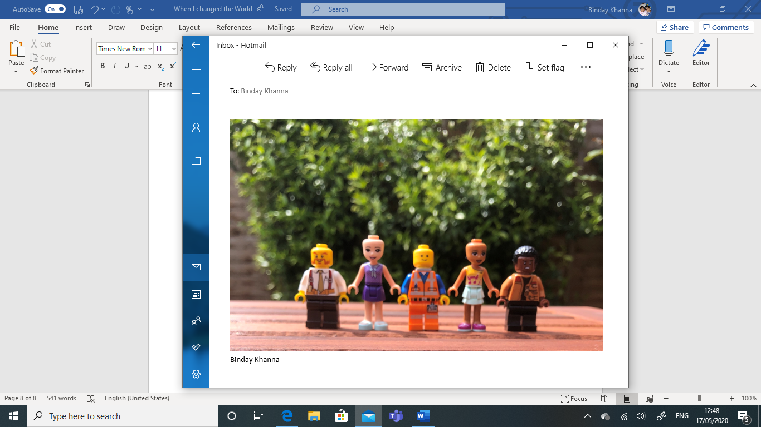

Hatred
I rubbed out the word hatred.
I wrote the word love.

Love
Light pink.

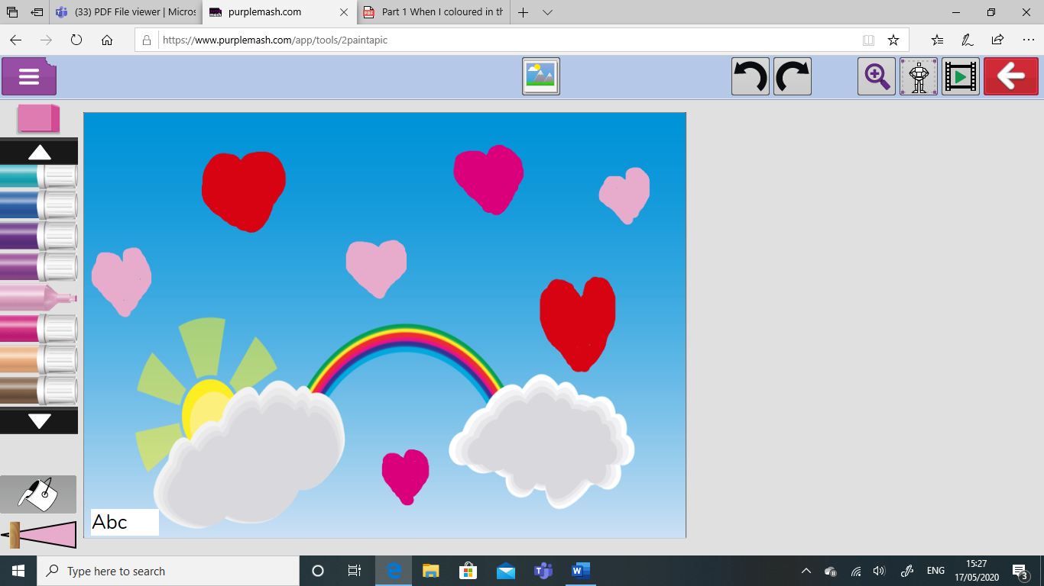
All over the world, people made friends with those around them. No one hated each other or disliked one another. I gave the world light pink.

Disheartened.
I rubbed out the word disheartened.
I wrote the word hope.

Hope.
Silver

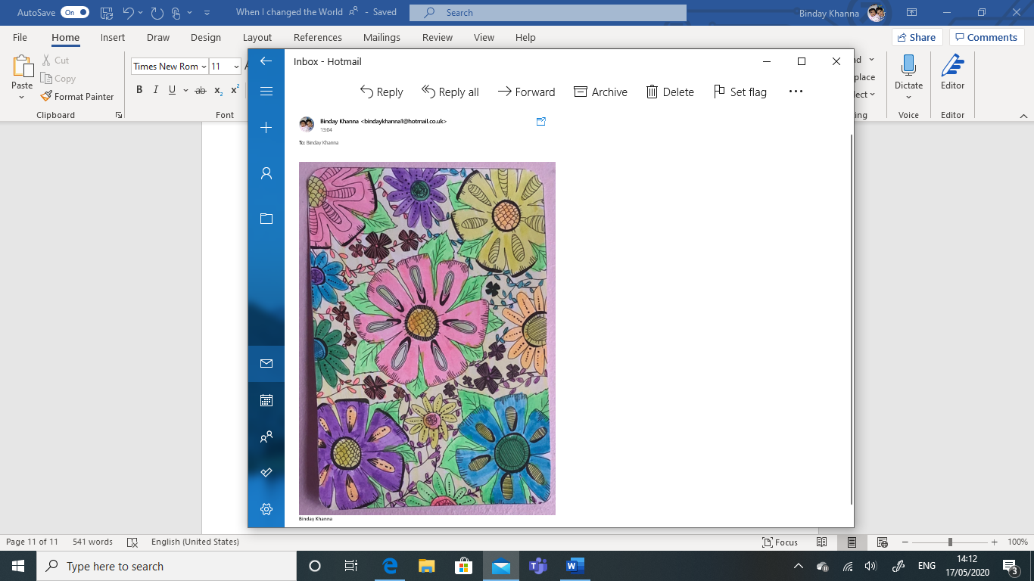
All over the world, people had faith. People believed. People had hope. Everyone was determined and saw the positives of things not the negatives. I gave the world silver.

