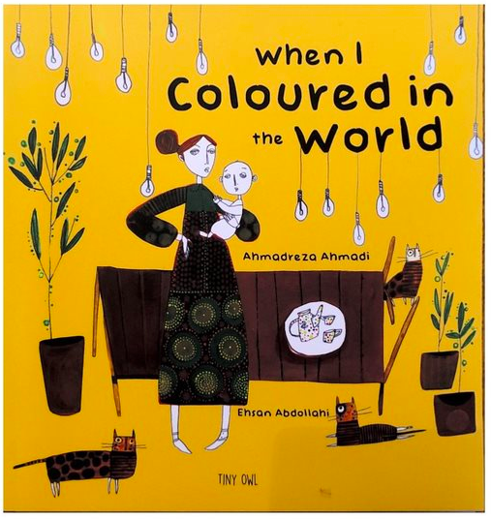
Think of what you would like to change in the world.
Write down word, then rub it out! Choose a colour and write a new word to replace it with.

Colours can make you feel different emotions like happy, sad or angry.
What colour is your new word? How does it make you feel?
What colours don't you like?

Write your own poem with all the new words you have chosen to make the world a better place. Pick your favourite colours and draw / create images which make you happy.

My mum gave me a box of crayons for colouring and an eraser. So guess what I did?

Discrimination

I rubbed out the word discrimination.
I wrote Equality.
Equality
Kaleidescope

With my Kaleidescope crayon I gave equality to the world. People of all races came together to celebrate.
I gave the world rainbow.

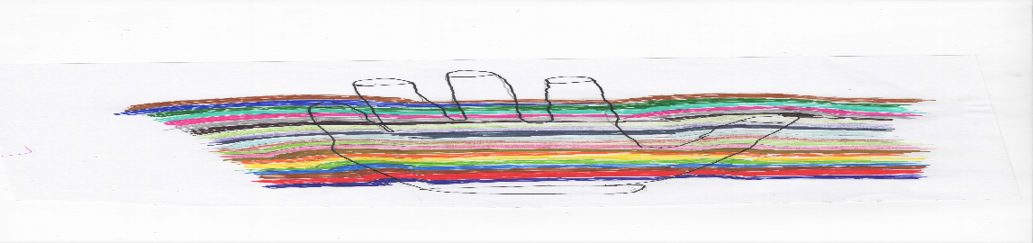

Hate

I rubbed out the word hate.
I wrote the word Love.
Love
Red

With my red crayon I gave the world love. All over the world people found love and were loved.
I gave the world red
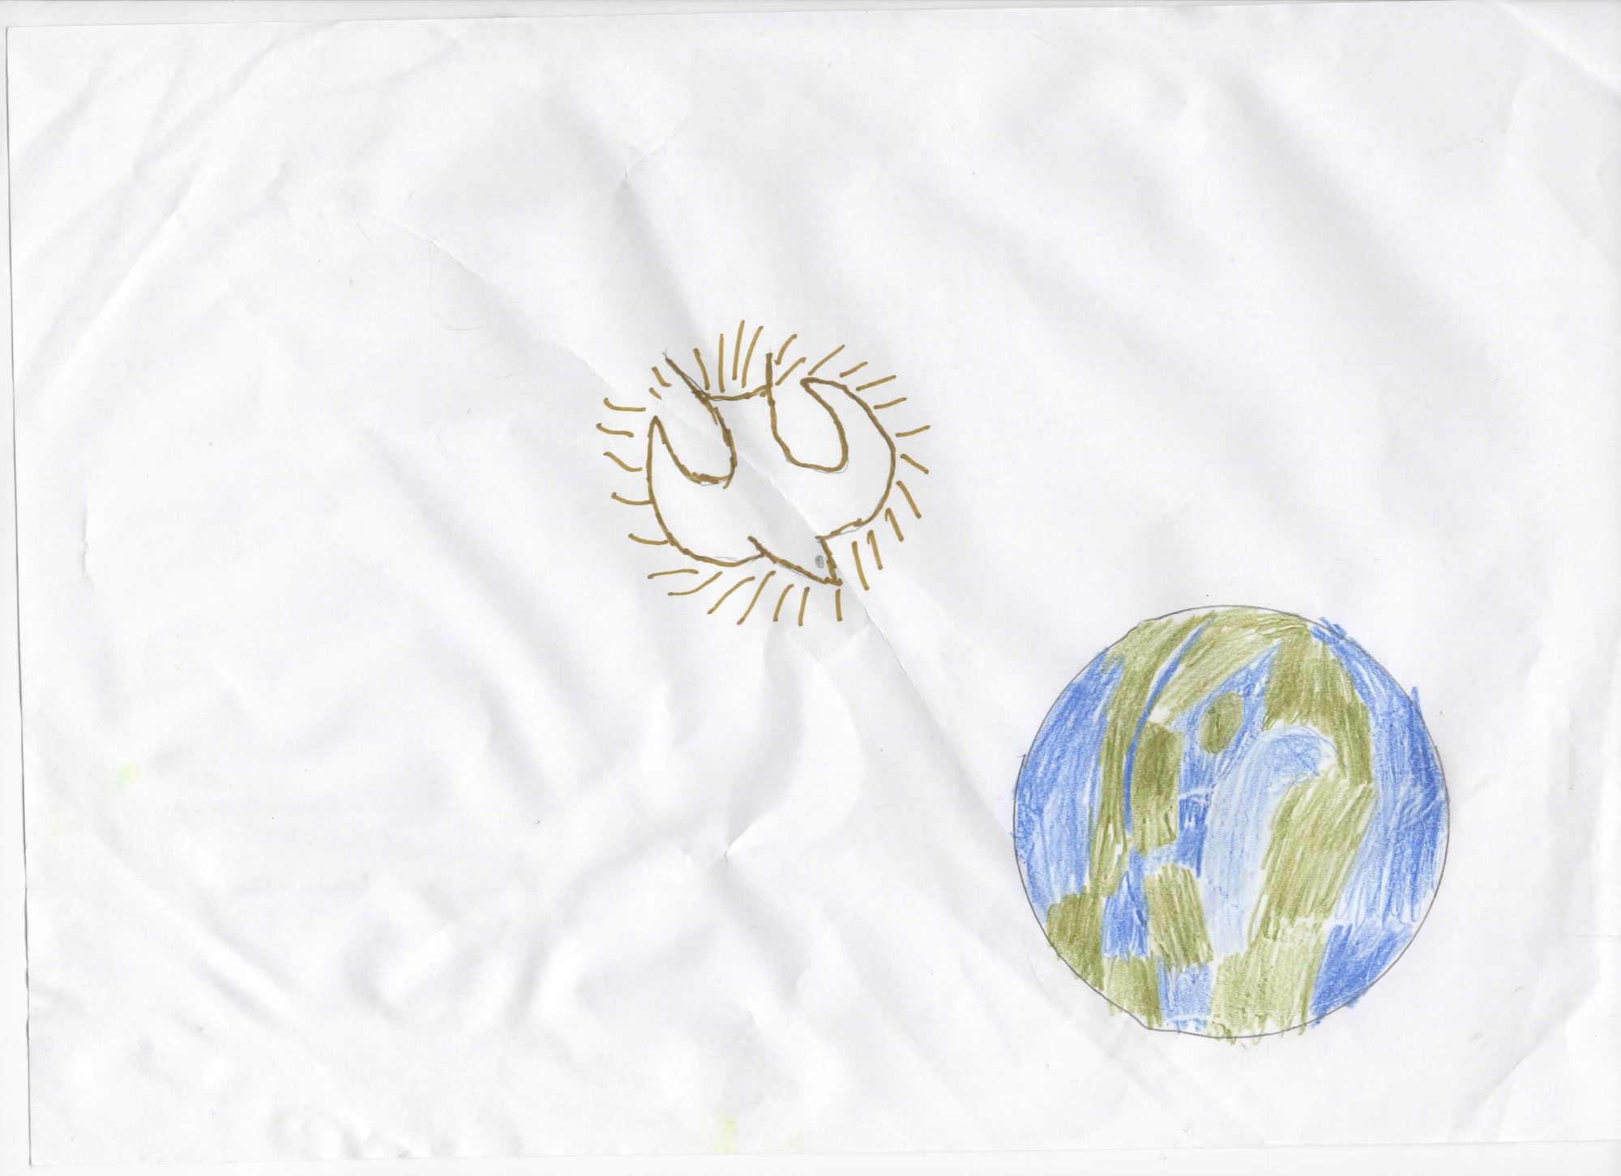

Foe
I rubbed out the word foe.
I wrote the word family.

Family
Green

With my green crayon I gave the world families. Everybody had a shoulder to lean on.
I gave the world green.


Pollution
I rubbed out the word pollution.
I wrote the word purity
Purity
Light blue

With my light blue crayon, I gave the world purity. People didn’t lie they were great friends and never talked behind their friends back.
I gave the world light blue.
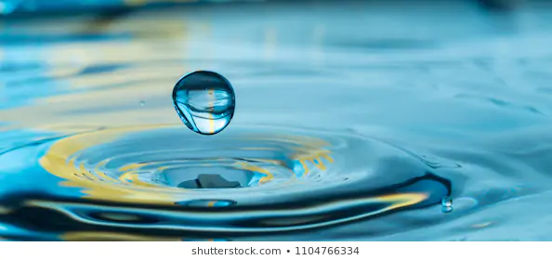

Boastful
I rubbed out the word boastful.
I wrote the word modesty.
Modesty
Purple

With my purple crayon I gave the world modesty. Every accepted everyone for who they are.

