When I changed the world.

One day, my mum gave me a box of crayons for colouring and an eraser to rub things out with. So, guess what I did?

ILL

I rubbed out the word ILL.
I wrote the word healthy in Jade-Green.

HEALTHY
JADE-GREEN

I gave the citizens of the world healthy bodies for staying immune to any type of virus that will occur. I gave the world healthiness.
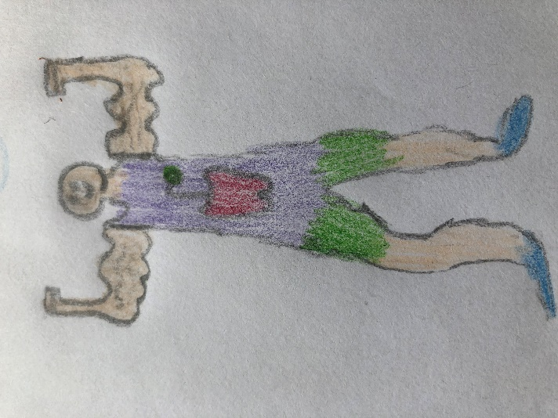
DEFORESTATION

I rubbed out the word DEFORESTATION.
I wrote the word evergreen in orange.

EVERGREEN
ORANGE

I gave the world evergreen trees that will not wither or burn away and destroy millions of homes. I gave the world evergreen trees.
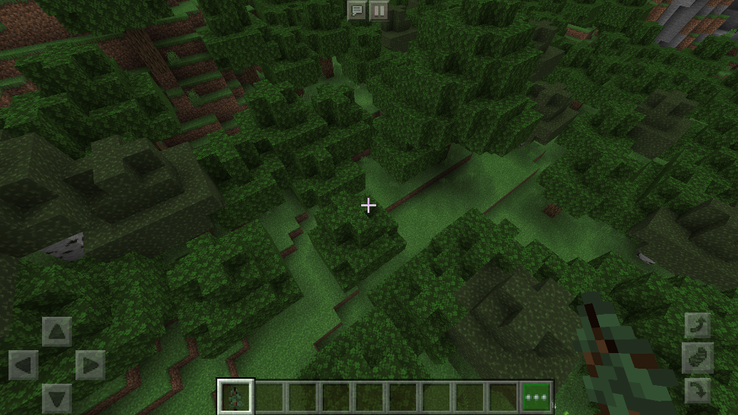
SPOILT

I rubbed out the word SPOILT.
I wrote the word grateful in violet.

GRATEFUL
VIOLET

With my violet crayon, I gave the entire world gratitude, so no one would take anything for granted. Everyone would know that in someone else's shoes, it would be quite different. I gave the world a whirlpool of gratitude and happiness.
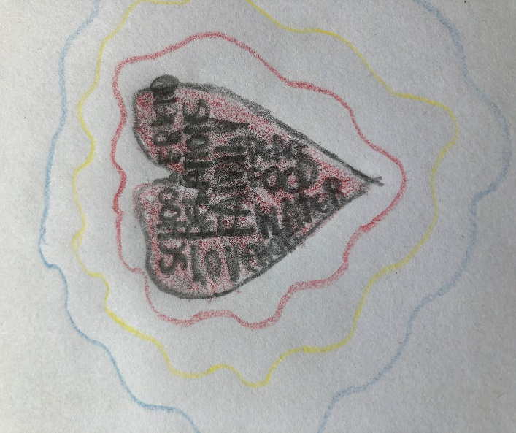
WAR

I rubbed out the word WAR.
I wrote the word harmony in teal blue.

HARMONY
TEAL BLUE

I gave our spherical planet peace and harmony. On millions of radios, it confirmed that every war had finished, and they all signed a treaty. I gave the world tranquility as everyone smiled.
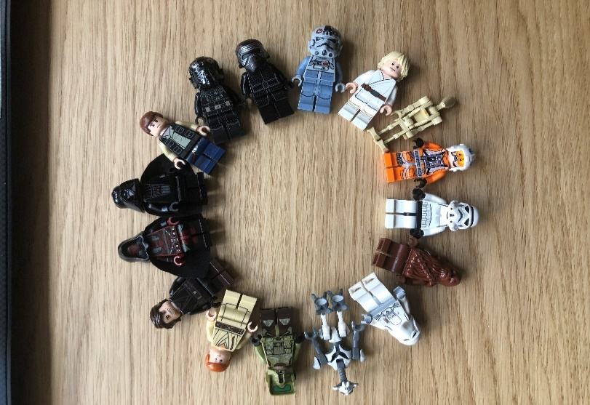
HEARING

I erased the word HEARING.
I wrote the word listening in vermillion-red.

LISTENING
VERMILLION-RED

With my red crayon, I gave the world working ears. Now, everyone would pay attention to every detail and there would be no faults because of not listening. I dispersed the sense of listening and eagerness to learn.
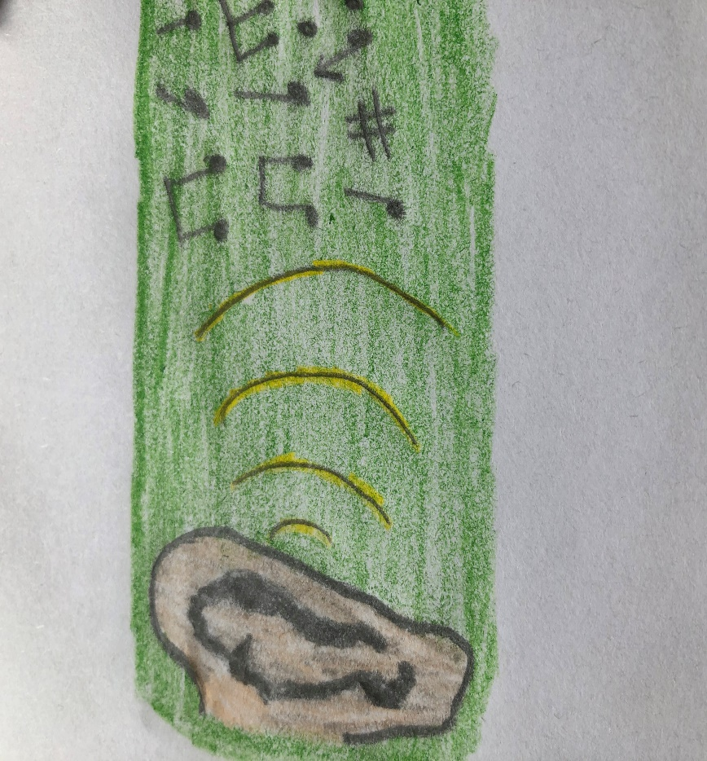
BOREDOM

I got rid of the word BOREDOM.
I wrote the word laughter in admiral blue.

LAUGHTER
ADMIRAL BLUE

With the tip of my colourful pencil, I presented the world with laughter. In every city, in every country, in every continent, people will be laughing out loud. The world now had laughter.
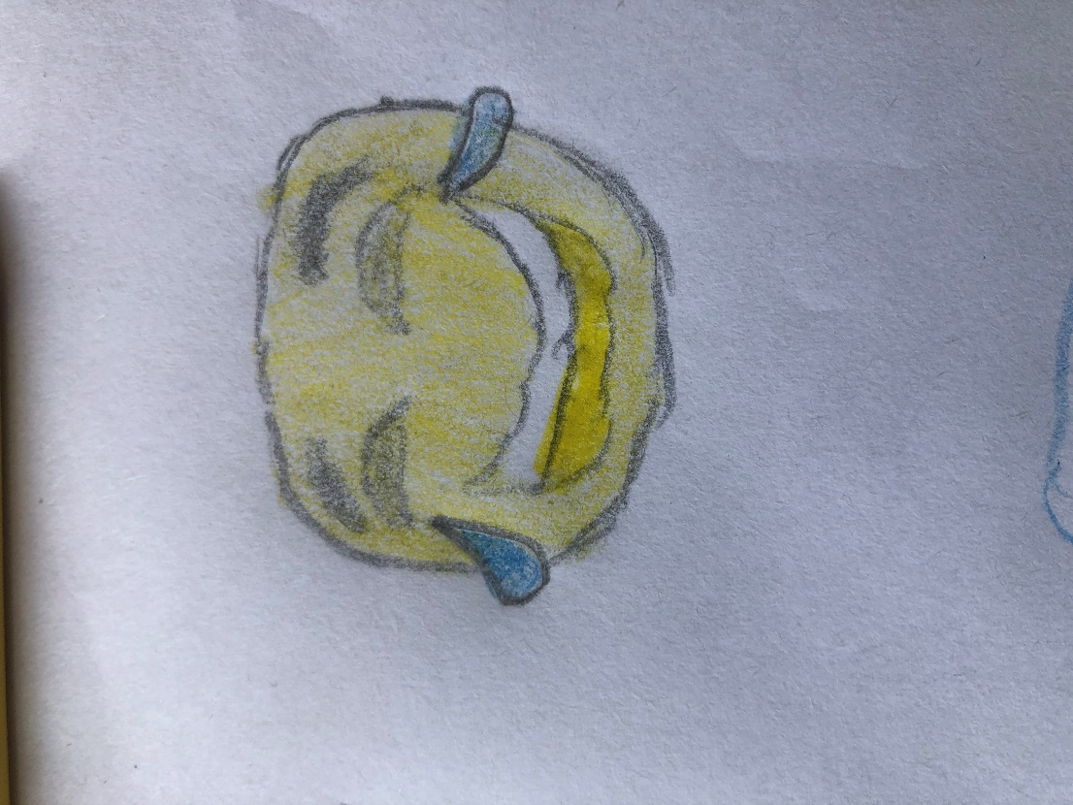
DECEIT

I erased the horrific word DECEIT.
I wrote the word honesty in silver.

HONESTY
SILVER

Fortunately, I gave every person in man-kind honesty, so they would not deceive someone by the truth. As many generations passed, the world would still acquire a monsoon of sincerity.
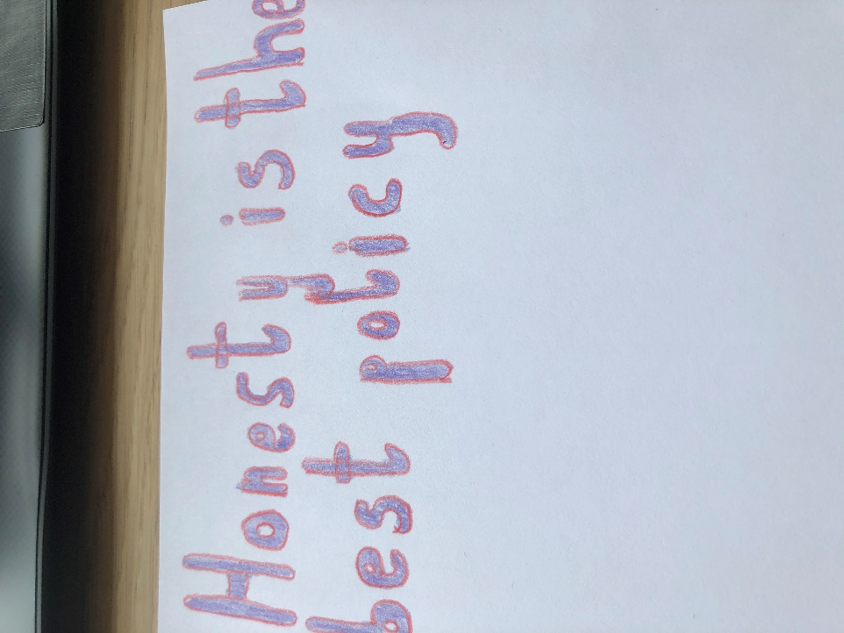
LITTERING

I rubbed out the word LITTERING.
I wrote the word recycling in neon pink.

RECYCLING
NEON PINK

After my success, I gave the world the heart to not litter and to not hurt our gracious world. The floor was now so shiny that some pictured it as an ice ring. I gave the world hygiene and a clean heart.
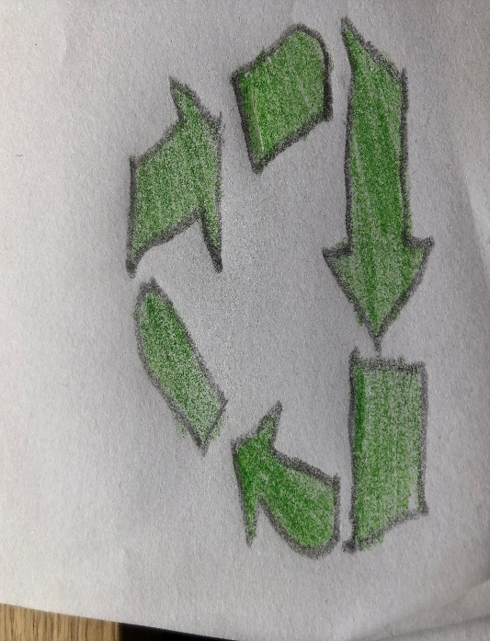
RUDE
I rubbed out the word LITTERING.
I wrote the phrase well-mannered in red and green.

WELL-MANNERED
RED AND GREEN.

While putting aside their differences, our friends and foes reunite and there would be peace once again. I gave the world good manners.
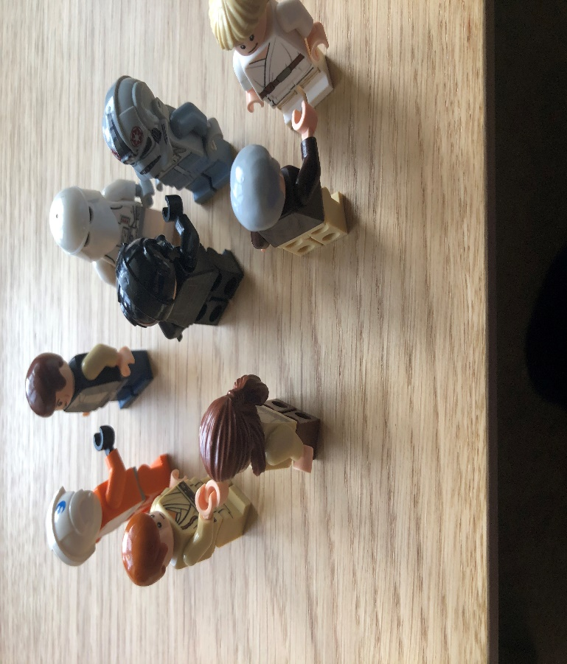
DISBELIEF

I rubbed out the word DISBELIEF.
I wrote the word hope in a kaleidoscope of colours.

HOPE
KALEIDISCOPE OF COLOURS.

Finally, the world was filled with hope. Despite this hard time, everyone still had hope in finishing any type of illness. I gave the world a downpour of Hope. Everyone was happy in our beautiful world.



