At St. Bernard’s School, we are looking forward to preparing for the coming of Jesus at Christmas. This time of preparation is called ADVENT

Advent begins this year on Sunday 27th November

Advent means ‘coming’. We think of the coming of Jesus when he was born but we also think of his promise that he would come again at the end of time. It is a time of waiting and preparing.

It is only in the last week of Advent that we focus upon the events to be celebrated at Christmas.
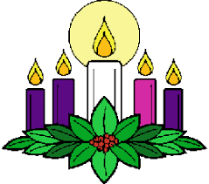

The Advent Wreath

The Advent wreath is a circular garland of ever-green branches representing eternity. On the wreath, five candles are typically arranged. During the season of Advent, one candle on the wreath is lit each Sunday as part of the Advent services. Each candle represents an aspect of the spiritual preparation of the coming of the Lord Jesus Christ.

Set on the branches of the wreath are four candles: three purple candles and one pink candle. In the centre of the wreath is a white candle. As a whole, these candles represent the coming of the light of Christ into the world.

On the first Sunday of Advent, the first purple candle is lit. This candle is typically called the prophecy candle in remembrance of the prophets, primarily Isaiah, who foretold the birth of Christ. This candle represents hope or expectation in anticipation of the coming Messiah.

Each week on Sunday, an additional candle is lit. On the second Sunday of Advent, the second purple candle is lit. This candle typically represents peace. Some traditions call this the Bethlehem candle, symbolising Christ’s manger. On the third Sunday of Advent the pink, or rose coloured candle is lit. This pink candle is customarily called the Shepherd’s candle and it represents joy. The third Sunday of Advent is known as ‘Gaudete’ or ‘Rejoicing’ Sunday. The fourth and last purple candle, often called the Angel’s candle, represents love and is lit on the fourth Sunday of Advent.

On Christmas Eve, the white centre is traditionally lit. This candle is called the Christ candle and represents the life of Christ that has come into the world. The colour of white represents purity. Christ is the pure Saviour.
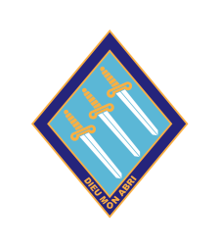

So, what happens at St. Bernard’s during Advent?
We will welcome in Advent in our Blessing of the Advent Wreath during our Assembly on 25th November.
During our Christingle Liturgy on 30th November we will remember especially the children of our world who may be living in ‘darkness’.
In class the children will discuss the importance of preparing for special events and how the Church gets ready for the coming of Jesus during Advent.
We will also take time to remember those who need our love, prayers and help at this holy time.
We will also take time to remember those who need our love, prayers and help at this holy time.
As a school community we will be taking part in the Love Christmas Campaign that aims to provide some joy and happiness to those most in need this Christmas – Bags of Kindness
Our Faith Ambassadors have created their own ‘Advent Giving Calendar’. Each class will fill a Christmas hamper which will provide some joy and happiness to those most in need this Christmas. These will be distributed to families in the local parish. This a way of letting people know we are with them, and they are not alone.
Beginning on 5th December we will begin to build up our school crib. Each day figures will be added to it so by the end of term we will have a nativity scene.

Suggestions for home activities

- If appropriate, at home have an Advent Wreath or calendar to ‘countdown’ the time of preparation for Christmas.

- Share together what you know about Advent as a season of the Church’s year.

- Use the CAFOD or Mission Together website to get a religious Advent calendar.

- Light a candle and pray for those who are suffering this Christmas



IMPORTANT FORTHCOMING DATES

Christingle Service
(30th November)

The Immaculate Conception
(8th December)
This feast marks the first stage of the existence of Mary, the mother of Jesus. She was ‘full of grace’ from the very beginning and co-operated with God throughout her life.

Advent Service in the Chapel
(14th December)

Christmas Day
(25th December)



FAITH PEACE LOVE JOY
Jesus, You came to be light
In our darkness.
Jesus, You came to be peace
In our conflicts.
Jesus, You came to be joy
In our sadness,
And to bring Your love
In our fears.
Amen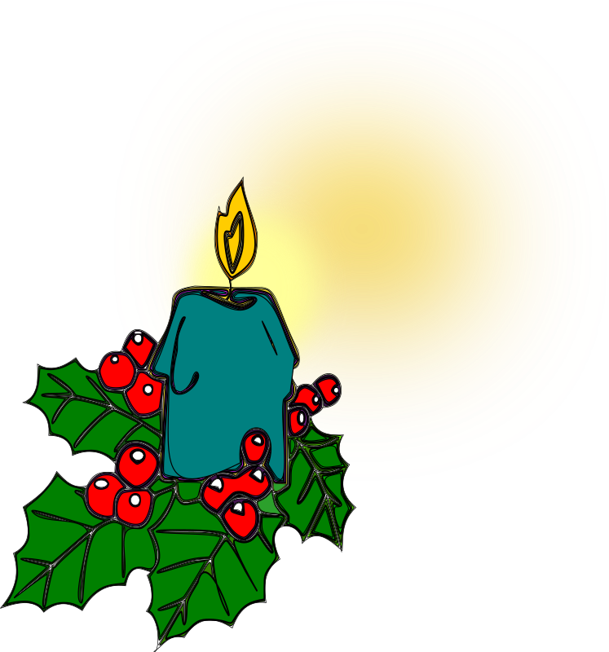

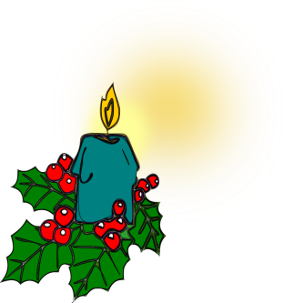

St. Bernard’s Preparatory School
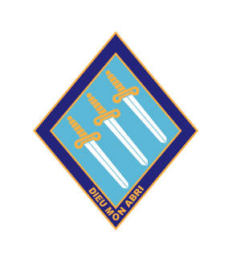

Religious Education Newsletter

Advent 2022


