When Year 5 Coloured in the World…
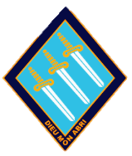

Enemy

I erased the word enemy.
I wrote the word friendship.

FRIENDSHIP
LIGHT BLUE

With my light blue crayon, I made friendships all over the world. People talked, laughed and worked together and people became friends with each other. Children learned from their parents and did the same thing to each other. In future generations this happened.

I gave the world light blue.

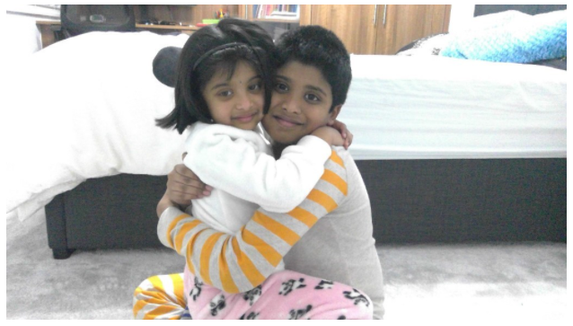

Akshay

Lockdown

I rubbed out the word lockdown.
I etched the word freedom with my light green crayon.

FREEDOM
LIGHT GREEN

Everyone could go out again and see each other. They could give away hugs to their self-isolating relatives. No more staying at home, no more teams, no more internet.

I gave the world light green.
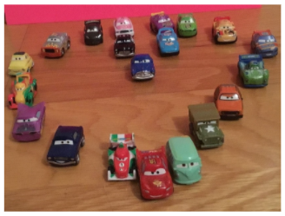

Satinderpal

Nervousness

I rubbed out the word nervousness and in my dark blue pencil I wrote self-belief.

SELF-BELIEF
DARK BLUE

My dark blue pencil made everyone confident. That means that no one will face a test without confidence. Nervousness will be a thing of the past and self-belief will be a thing of the present.

I gave the world dark blue.

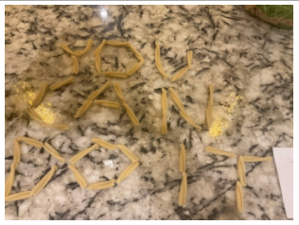

Marley

Cowardice

I rubbed out the word cowardice.
I wrote the word bravery with my platinum crayon.

BRAVERY
PLATINUM

People were no longer cowards and they no longer ran away from problems in their life. They became lion hearted and courageous. They had been able to overcome their fears and face them without any hesitation and distractions.

I gave the world platinum.

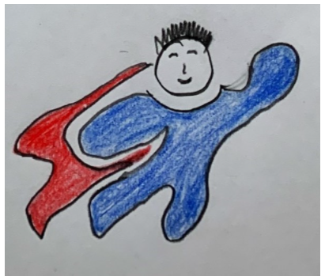

Sahas

Lost

I rubbed out the word lost and using my yellow crayon replaced it with faith.

FAITH YELLOW

I gave the world faith to encourage everyone to believe in themselves and to be brave. I wanted everyone to feel like they were confident so no one was ever scared again.

I gave the world yellow.

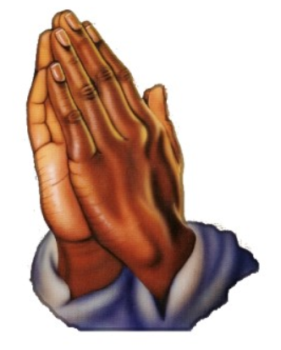
Shaan

Slavery

I rubbed out the word slavery.
I wrote the word freedom with my azure blue crayon.

FREEDOM
AZURE BLUE

All over the world, the slaves became free. Their ragged clothes became new. Relieved slaves danced in the emerald meadows celebrating their new found freedom. They sniffed the flowers and lay on the grass and savoured every sound and touch. They danced around like children because they were free! Slavery will become a thing of the past and freedom will become a thing of the future.

I gave the world azure blue.

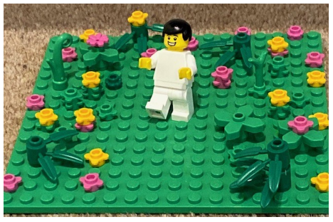
Jayan
Inequality

I rubbed out the word inequality.
I replaced it with equality.

EQUALITY
BROWN
People would no longer be judged by their appearance, by the colour of their skin, by their religion but by their personality. People would treat everyone equally.

I gave the world brown.
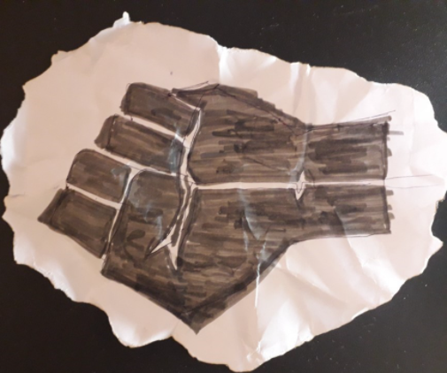

Twinkle

War
I thought carefully. I rubbed out the word war.
I took my pearl white pencil and replaced it with peace and tranquility.
PEACE AND TRANQUILITY
PEARL WHITE
There was no racism, no bullying, no war. Everywhere, people were treated with love.
I gave the world pearl white.
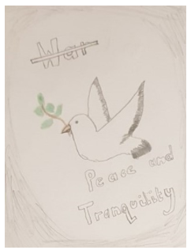
Arjun K

Extinction

I rubbed out the word extinction.
I wrote the words look after endangered animals with my mint crayon.
LOOK AFTER ENDANGERED ANIMALS
MINT
All over the world people looked after endangered animals. We have to look after these animals because they are equal to us, we are all the same. If we don’t look after these animals, they will become extinct and people in the future will not be able to enjoy and study these amazing, beautiful animals. We are very lucky. If we want these animals in the future, we have to act fast.
I gave the world mint.

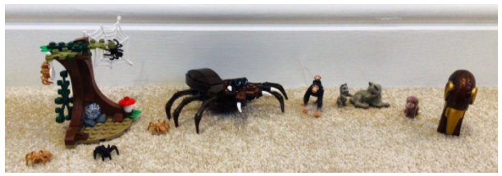
Mannat

Hatred

I rubbed out the word hatred.
I took out a crimson red crayon and wrote the word love.

LOVE
CRIMSON RED

No one in the world was hated and everyone played together happily and carefully. The world was full of love. Everyone gave each other hugs and they were all loving towards their enemies.

I gave the world crimson red.

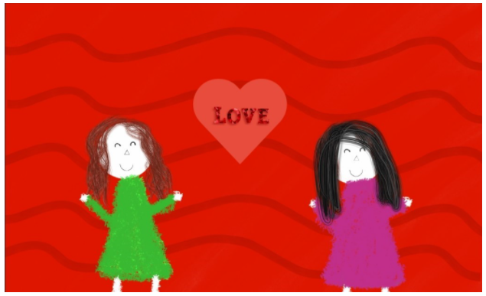
Abeni

Famine

I erased the word famine and wrote the word nourishment with my apricot orange crayon.

NOURISHMENT
APRICOT ORANGE

Nobody in the world lived in poverty and was not treated in an unkind manner. Homelessness faded away and instead of exchanging a frown with the poor, people loved them and cared for them. Poor people had all they needed, food, water and shelter.

I gave the world apricot orange.

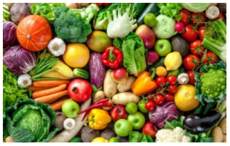

Aarush

Lie​
​
I rubbed out the word lie and wrote the word truth.​
​
TRUTH ​
PURPLE​
​
Immediately, each and every person, who had previously told a lie, confessed about how they had been deceitful. Many people were furious at them but they eventually appreciated that they told the truth.​
​
I gave the world purple.​

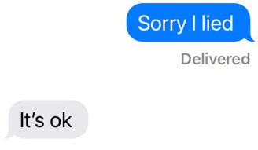

Aleena

Lockdown

I rubbed out lockdown and wrote freedom.

FREEDOM
EMERALD GREEN

All over the world, everyone opened their doors and ran across the streets playing, chatting, laughing.

I gave the world emerald green.

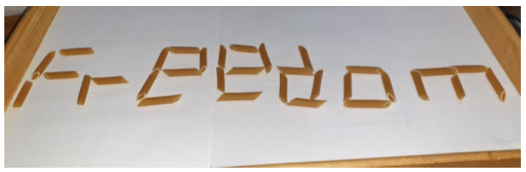

Nivaan

Loneliness

I rubbed out the word loneliness and wrote the word family.

FAMILY
ORANGE
​
With my orange crayon, I gave the world families!​ Some people are homeless and poor, so they need families.​ Friends are the family we choose ourselves.

I gave the world orange.

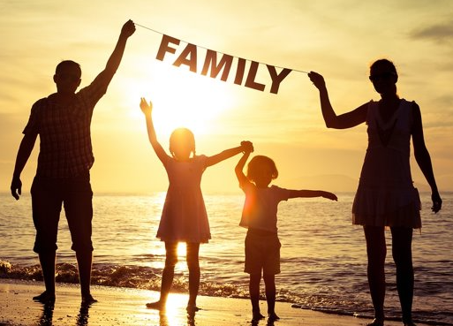
Annaya

Anxiety

I rubbed out the word anxiety. I got out my purple crayon and wrote the word self-confidence.

SELF-CONFIDENCE
PURPLE
All over the world, people who were not confident became resilient and confident. They had pride in their work and always accepted feedback when given. They did not care at all if people discouraged them and kept their head held high. Everyone was a better person in the whole world. The Earth was filled with self- confidence.

I gave the whole world purple.

Vihaan

Disabled

I erased the word disabled.
In its place I wrote cure.

CURE
DARK BLUE

Wheelchairs were left unused as there were no more disabled, the blind could see, the deaf could now hear, and those that thought that they would they would not recover, were proved wrong and given the chance to live their normal lives.

I gave the world dark blue.

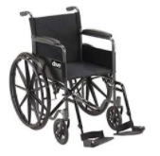

Divya

Pandemic

I rubbed out the word pandemic and using my sky-blue crayon wrote the word normality.

NORMALITY
SKY BLUE

All the people who had been affected were then well and all those people suffering in the hospital were then released and everyone who had caught the virus were given the vaccine. All the sorrow and despair turned to happiness and joy. Those who were not able to see their family went to see them to have a meal and holiday.

I gave the world sky blue.
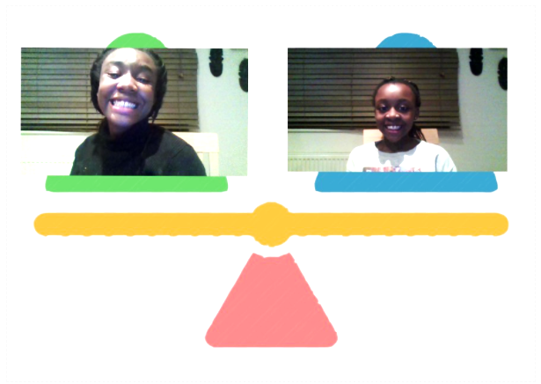

Okuse

Selfishness​
​
I rubbed out the word selfishness.​
With my white crayon I wrote the word humility.​
​
HUMILITY
WHITE​
​
No one was ever selfish again. Around the world people cared for everyone and put others in front of them.​

I gave the world white.​

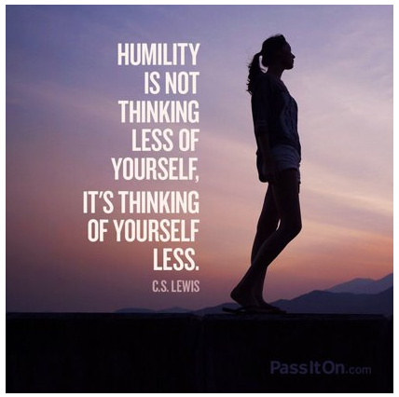

Vedanth

Boredom

I rubbed out the word boredom and with my orange crayon I wrote the word play.

PLAY
ORANGE

Everybody stopped being bored went outside and played with each other it was fun. We all made new friends too. Everybody was smiling at each other, I did this because I have a friend and I don’t know what I would do without her, so I thought evrybody might need a friend in life so ilet everybody have fn with their friend.

I gave the world orange.

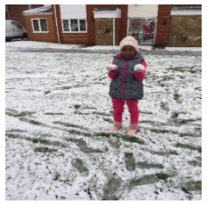
Ayannah

Deforestation

I rubbed out the word deforestation.
I wrote the word replant.

REPLANT
SHAMROCK GREEN

With my shamrock green crayon, deforestation instantly stopped. People started to realise how important trees were and they shouldn’t cut them down just for palm oil. Plants of all kinds appeared everywhere.

I gave the world shamrock green.

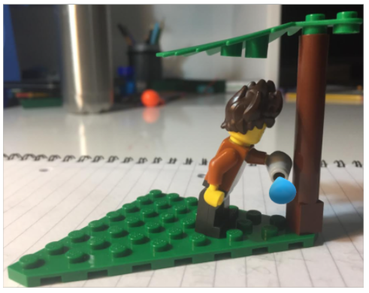
Aisheek
Hatred

I rubbed out the word hatred.
I wrote the word love.

LOVE
CRIMSON RED

With kindness everybody laughed with joy. Everybody shared their food with the poor and gave blankets. No more bullying. No more hatred. No more hostility.

I gave the world crimson red.

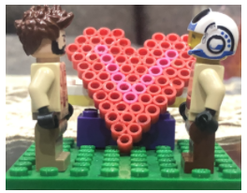
Anisha

Barren

I rubbed out the word barren.
I wrote the word fertile.

FERTILE
EMERALD GREEN

The land that was once barren and dry, became fertile and luscious. The extinct animals were brought back once again and the waters glistened under the heat of the shining bright sun. All seas were safe to swim in and all land was safe to tread on.

I gave the world emerald green.

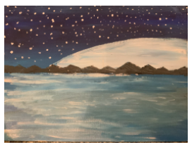
Shariya

Anger

I rubbed out the word anger.
I wrote the word serenity.

SERENITY
PINK

With my pink crayon I wrote serenity. Everyone’s mind became calm all over the world and people became peaceful with other people.

I gave the world pink.

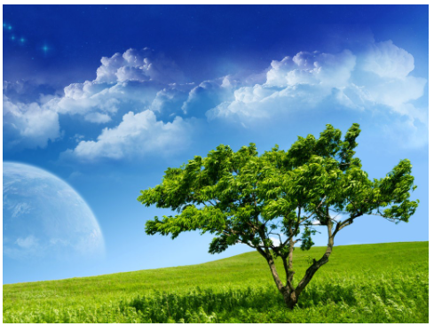

Daniel

Greed

I rubbed out the word greed.
I wrote the word generosity.

GENEROSITY
CORAL ORANGE

All over the world people were being generous. People were showing that they cared for each other in the hard times and good.

I gave the world coral orange.

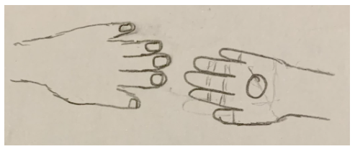

Daya

Injustice

I rubbed out the world injustice.
I wrote the word fairness.

FAIRNESS
GREEN

No one in the world was treated unfairly. No more racism, no more injustice. Everyone was treated fairly.

I gave the world green.

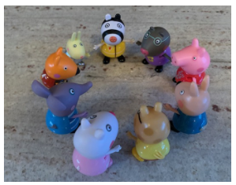
Jagat

Poverty

I took my eraser and rubbed out the word poverty.
With my gold crayon I wrote the word wealth.

WEALTH
GOLD

No one lived in poverty and everyone had food and water. Without this 1/8 of the world might become extinct. Every penny counts.

I gave the world gold.

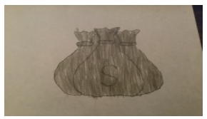

Sai

Lockdown

I rubbed out the word lockdown.
I replaced it with the word freedom.

FREEDOM
SILVER

Lockdown ended and the coronavirus was a thing of the past. In return, the whole world was given freedom from the remote learning and children could return to school and adults to their jobs like we used to do before. Once every one heard the news on the radio, everyone will jump for joy and finally meet their friends for the first time in forever.

I gave the world silver.

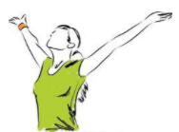

Rehan
War

I erased the word war and wrote the word harmony with my red crayon.

HARMONY
RED

Every war stopped.

I gave the world red.

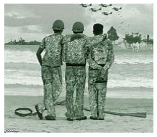
Joran

Hunger

With my eraser I rubbed out the word hunger and wrote food with my brown crayon.

FOOD
BROWN

All over the world everyone had enough food to eat, there was no more starvation or hunger.

I gave the world brown.

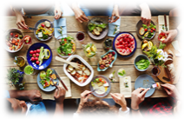
Arjun S

Doubt
I rubbed out the word doubt and using my light blue crayon I wrote the word hope.

HOPE
LIGHT BLUE

No one will feel like they can’t do something or they’re not as good as someone else.

I gave the world light blue.

Sara

Anger

I rubbed out the word anger.
I wrote the word serenity.

SERENITY
PINK

With my pink crayon, I gave serenity to the world. Everybody was calm and did not get angry.

I gave the world pink.

Shubhay
Selfish

I rubbed out the word selfish.
With my purple crayon I replaced selfish with sharing.

SHARING
PURPLE

Now the world was full of people sharing and thinking of each other. People were reminded not be selfish and to think carefully about what others might not have.

I gave the world purple.

Ayaan
Dry

I rubbed out the word dry.
With my green crayon I wrote the word rain.

GREEN
RAIN

Now rain had fallen all of the crops sprouted
and food had grown.

I granted the world green.

Gunjot
Anger

I rubbed out the word anger. I picked up my pink crayon and wrote serenity.

SERENITY
PINK

The world was full of kindness as people spent time with others.

I gave the world pink.

Amrit

Abandoned
I rubbed out the word abandoned and wrote the word teamwork.
TEAMWORK
PURPLE
Everybody worked together and accomplished so many goals.
I gave the world purple.
Nayan

