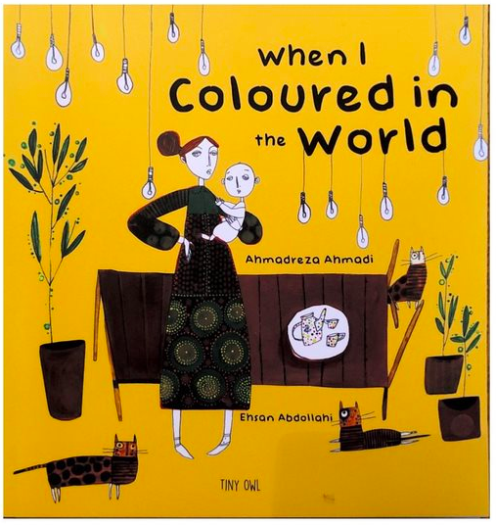
Think of what you would like to change in the world.
Write down word, then rub it out! Choose a colour and write a new word to replace it with.

Colours can make you feel different emotions like happy, sad or angry.
What colour is your new word? How does it make you feel?
What colours don't you like?

Write your own poem with all the new words you have chosen to make the world a better place. Pick your favourite colours and draw / create images which make you happy.

My dad gave me a box of crayons to colour and an eraser to rub out with when I was younger. Guess what I did?

Drought
I rubbed out the word drought with my eraser.
I wrote the word rain with my dark blue crayon.
Rain
With my dark blue crayon I made rain shower the world from above.
Now everybody needed umbrellas!
I gave the world blue
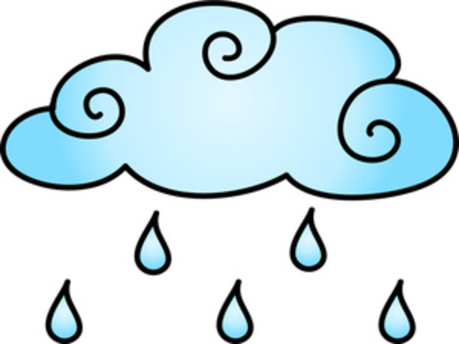

War
I rubbed out the word war with my eraser.
I wrote the word peace with my pink crayon.
Peace
With my pink crayon I spread peace across the world.
All the wars stopped!
I gave the world pink.
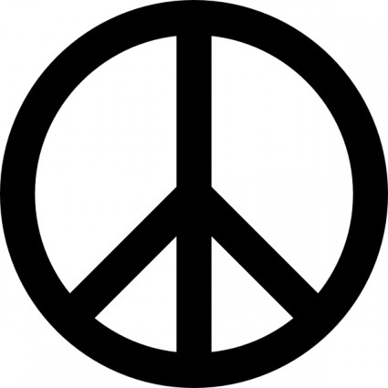

Hate
I rubbed out the word hate with my eraser
I wrote the word love with my red crayon.
Love
With my red crayon I gave the world love.
Suddenly everyone cared about each other!
I gave the world red!
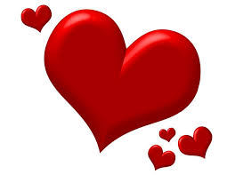
Disease
I rubbed out the word hate with my eraser
I wrote the word healthiness with my my dark green crayon.
Healthiness
With my dark green crayon I gave the world healthiness
Suddenly all the ill people were fit and moving about
I gave the world dark green!
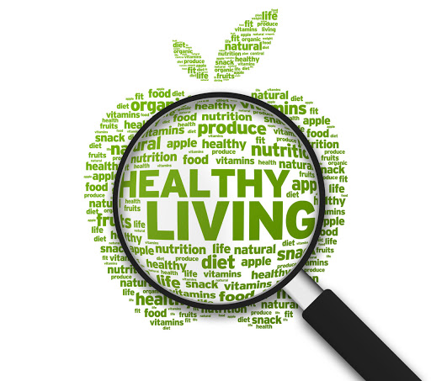
Famine
I rubbed out the word famine with my eraser
I wrote the word plentiful with my golden crayon
Plentiful
With my golden crayon I gave the world plentiful amounts
Suddenly no one was hungry!
I gave the world gold.
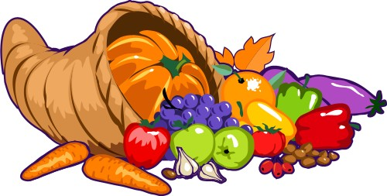

Pain
I rubbed out the word pain with my eraser
I wrote the word comfort with my grey crayon
Comfort
With my grey crayon I gave the world comfort
Everyone was relieved of pain and comfortable
I gave the world grey!
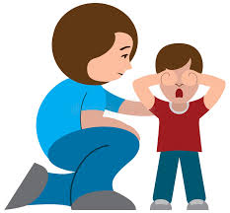

Loneliness
I rubbed out the word loneliness with my eraser
I wrote the word unity with my light blue crayon
Unity
With my light blue crayon I gave the world unity
Everyone was joined in love and harmony
I gave the world blue!
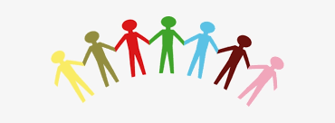

Discrimination
I rubbed out the word discrimination with my eraser
I wrote the word equality with my orange crayon
Equality
With my orange crayon I gave the world equality
Everyone started to treat one another equally
I gave the world orange!
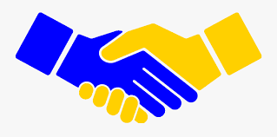

Cruelty
I rubbed out the word cruelty with my eraser
I wrote the word kindness with my light green pen
Kindness
With my light green crayon I gave the world kindness
Everyone started to show kindness to each other
I gave the world green!
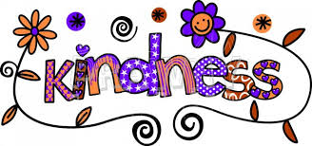

Savage
I rubbed out the word savage with my eraser
I wrote the word tenderness with my peach crayon
Tenderness
With my peach crayon I gave the world tenderness
Everyone started to show love and care towards each other
I gave the world peach!
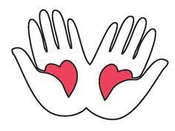

Darkness
I rubbed out the word darkness with my eraser
I wrote the word light with my yellow crayon
Light
With my yellow crayon I gave the world light
All the wrongly lead people were suddenly put onto the right and light path
I gave the world yellow!
